Exploration of a Windows Explorer Application

I began looking for apps that would mimic Windows Explorer to some degree because I wanted to create an application to send files via WiFi from one Windows PC to another rather than copying them to a flash drive and carrying it to the other PC to copy them that way. Rather than have the user enter the path to the file into the file transfer application I wanted the user to be able to select it from a Windows Explorer application and, via the use of WiFi, send it to the other PC.

First I found a Microsoft presentation but quickly determined that it just presented how to have a split panel form. It had nothing about using the form to display the tree and file views in the two panels. So hardly what I was looking for.

Via further internet searches I then found a couple of possibilities. The first was that of Raj Lai on the CodeProject "A Windows Explorer in a user control" with his TreeExplorer Demo Project directory and its associated Explorer Tree directory. I downloaded and ran it and found it to be very fast as it immediately displayed the tree for the C drive. However, I couldn't get an event for the selection of a particular file in the file view.

Although I could make modifications to the Demo Project I couldn't do so to the files of the Explorer Tree where the presentation of the Tree View and File View portions of the Explorer Tree seemed to actually occur. That is, I could edit the ExplorerTree.cs file but those changes didn't seem to have any effect. I also couldn't run the debugger with it to locate potential problems. There was a WindowsExplorer.dll associated with the Explorer Tree directory in the bin Debug and Release directories that caused me to think that it was where the actual executing code was located and which was responsible for the speed with which the application could display the tree.

Since at that time I didn't care to find out how to modify the code so that file view click events could be received and handled – that is, determine how to rebuild the DLL to find out that would be successful – I decided to try the other application. It was that of K Niranjan Kumar as presented on "C# Corner" as WinExplorer. There were comments about it concerning slowness but when I first tried it I found it slower then TreeExplorer but not unacceptably so. Therefore I tried it and was able to add a SelectedIndexChanged event handler for the file view and get events when I clicked on a file presented in the file view panel. So I decided to use it as the explorer portion of my intended file transfer application.

Little did I know then what I was getting into and how learning how to make modifications to Raj Lai's application might have been quicker and resulted in a much faster product. But it did make me more knowledgeable about Microsoft's Tree and File View using C#.

The comment on how long it took has to be because it searches a drive for all possible folders and files before displaying anything. And then only that portion directly below that was selected rather than all. This takes a lot of time on the C: drive.

The sample display of the tree and file views of K Niranjan Kumar (Windows Explorer in C# - C# Corner) is below showing a possible A floppy drive, a C drive with only thee child folders, and a ROM drive with a Sairam folder selected to show its files. Note that that there are special images associated with My Computer, A:\, and RECYCLED as well as a closed folder image for unselected folders and an open folder image for the folder selected to display its contents in the file view.
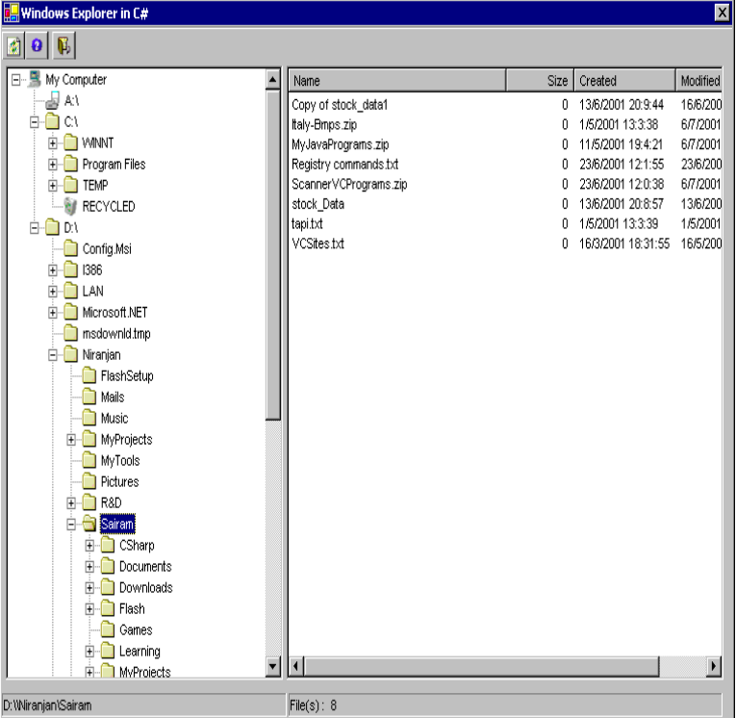

However, I never found it to produce such a diagram. For instance, it always displayed a whole set of drives even though they weren't usable. (I made a change to avoid this. The IsReady property of a drive allows ignoring drives that can't be used.)

And it would fail to display folders that were under a folder. For instance, it would display 4 hidden folders of the C:\ drive and only the first 2 of the many visible folders. In another instance when one of those visible folders was selected it would display the one subfolder below it. But when that folder was selected it failed to display the one folder below it.

This was after correcting for the FullPath property sometimes (most of the time?) including an extra backslash after the C:\ of the drive in the FullPath.

But this lack of C:\ drive folders is likely to illustrate the problem of quitting the tree population when encountering a folder without the proper permission to access it. Now that I found out about that, its likely that that is the reason only 3 folders are shown for the C:\ drive plus the Recycle bin that is likely marked in Windows as a hidden folder. Terminating the populating of C:\ folders dramatically reduces the delay before the form is displayed.

Since the product about which I will be presenting in this post along with the modifications that I had to make and those that I chose to make, I will at this point present K Niranjan Kumar's copyright agreement.
AUTHOR COPYRIGHT AGREEMENT
As an author, you AGREE that you have not copied article contents, images, ideas or other material from somewhere else and you are solely responsible for these contents. C# Corner and its affiliates including sponsors and advertisers in no event responsible for the contents and any related material published by you.

I soon found out that the WinExplorer application was a great deal – substantially greater – more slow than what I first thought. This was because as it recursively iterated through the directories of the C drive of the computer it got an exception due to a folder for which I had insufficient privilege to access. Since I could run the debugger with it I was able to find that it failed to catch the exception and continue. Therefore, the populating of the tree folders ceased with only about 5 folders in the tree view. When I made the modification to continue, ignoring the directory causing the exception, and to populate the tree view with other directories I found out the reasons for the comment(s) about how slow it was.

It then took so long that I wondered if it was caught in a loop. Which it was of course as I followed it via the debugger for a while. The recursion loop of the directories with the application following each one to its end point, then continuing with the next directory up one level, and continuing until every possible directory of the C drive and the flash drive had been added to the tree view even though only the child folders just below the C drive and flash drive would be visible when the form was first displayed and the user selected the drive for which they wished to view its folders / directories.

So I stopped using the debugger to follow what was happening and did other things. Eventually, after I forgot that I had left it running, the split panel form with the tree view displayed. I suppose that I should have returned to Raj Lai's Tree Explorer at that time to try to fit it to my purposes. But that is in hind sight. I would have learned about creating dll's and such but probably a lot less about the workings of tree view.

Other changes to WinExplorer

One of the easy changes towards the beginning was to take out the multitude of possible flash drives and only consider the computer drives that were actually available on the computer. On my old Windows 7 computer that I was using, this also eliminated the D drive since it had failed.

I also switched from the tree event handler of the download to a mouse click event handler so I could get the full sequence of changes. This was so I could build up the path for myself before I recognized that I could use the FullPath property (with a correction to remove the extra \ following the drive (C:\\ for instance rather than C:\) that the FullPath was returning). This since I was going to need the full path when a file was selected in order to copy the file to the second PC. (Note: Since FullPath is a Microsoft C# method, perhaps the extra \ was due to my using a 2010 version of C# that may have been corrected in later versions and whatever version Mr. Kumar used.)

Due to the need to remove My Computer\ from the path to only have the actual path (that is, My Computer is only a placeholder and not a part of an actual path) and the need to remove the extra backslash, I created another method (CompletePath) that also saves the latest FullPath for the current tree node where it can be retrieved later. At the end when I also added My Documents and My Pictures as root nodes, I used it to remove those sequences from the nodes full path as well.

Also, the code directly used Directory.GetDirectories and Directory.GetFiles that could throw exceptions due to lack of permission. To avoid needing to have code to catch such exceptions every place that the Directory methods were used, I added my own GetDirectories and GetFiles methods to catch any exception and return a null string. Although this meant that the foreach loops that enumerated the directories or files and didn't do so of the string[] array had a count of 1 rather than 0, so I had to check if the string was "". But it did mean that an exception would not occur without being caught and stopping the populating of the drive folders early.

Another change that I made was to check whether a directory was supposed to be hidden and skipping it if it was. That is, the same as if the application didn't have permission to access the directory. Therefore, the special code to check for RECYCLE is no longer necessary. But before I made the change about hidden directories I changed the code to also check for the recycle name of my computer.

Yet another was that the file size displayed via the PopulateListView method was set to 0 as can be seen in the above form image. This was because it was set to 0 rather than using the fInfo.Length from
var fInfo = new FileInfo(l_strFile);
Also, the ConvertFileLenToKB method stopped one short of converting the file size to the corresponding number of kilobytes which I fixed.

Reduction of the Delay

Something that occupied me for quite some time was an idea I had to only go two deep for child directories of a drive. This, of course, didn't cause the tree view to show the plus box in front of grandchild folders that had their own child folder(s). But I thought I would let the user choose the path of interest and click on the plus box of the drive's child folder to cause its child folders to be displayed. When that happened I would add another set of child folders (the great grandchild folders) to the drive's collection. This would cause the form to be displayed after the two deep set of folders had been added to the collection of each of the available drives. Then further folders could be added depending on the user's choices.

I pursued this approach for quite some time without success. I tried and tried but never got anything further to display or paths with only root lines to the grandchild folder get a plus box prior to it. Although I did find that the tree view code just displayed the child folders of a folder with a plus box without causing an event. And I couldn't find an event handler that could be added that would field it. So I had to attempt to add child or grandchild folders of the folder name (depending upon whether the drive's child folder name was clicked or the visible grandchild that as yet didn't have a plus box) that did cause an event that could be used to display any files of the folder. But I couldn't use that event to add further folders to the collection and have the tree view display them.

So I never got it to work and I finally gave it up. Shortly before that I thought of another way to speed up the display of the form and its tree view. This was to supply an IgnoreDirectory.dat file that would contain a list of folders by full path name that aren't of interest to the user. As I have done in other projects, such a file would be placed in the path of the location of the executable and the application would search backwards from that location until it found the file and, if available, it would read the paths from the file into an IgnoreDirectory table. Then, as with the hidden folders and the no permission folders, the table would be checked and if the current path was found in the table, the folders of this path would not be followed to populate the collection.

This allowed the form to be displayed much quicker even after I also added My Documents and My Pictures root nodes so the folders of those paths also had to be searched. For instance, yesterday afternoon the delay was about 10 seconds. But this time can vary quite a bit. For instance this morning it took about a minute. Yet this afternoon it was about 7 seconds. So it depended a great deal on what the computer was doing "under the covers". For instance, virus checking is one possibility.

This reduction was mostly due to the inclusion of a number of directories as the top of the C:\ drive. One in particular the C:\Windows folder which on my PC has 144 items with what looks like about half being directories with most having multiple child directories.

The complete list of directories that I included to be ignored is
C:\ADO.NET Samples
C:\cygwin
C:\cygwin_mono
C:\cygwin64
C:\FlowAV
C:\FPC
C:\GNAT
C:\GNATPRO
C:\Go
C:\gtk+-gtkmm-3.22.0-mingw32-6.2.0-posix-dwarf
C:\GtkAda
C:\lazarus
C:\linqtest5
C:\Linux
C:\MicrosoftVisualStudio10.0
C:\mono
C:\PerfLogs
C:\Program Files
C:\Program Files (x86)
C:\PyGUI-2.5.3
C:\python
C:\Python32
C:\sloccount-2.26
C:\SPARK
C:\SPARK-Discovery
C:\swsetup
C:\Users
C:\Windows

Program Files, Program Files (x86), GNAT, GNATPRO, etc being obvious for their lack of interest to my goal to use the Tree and File Views to select files to be transmitted via Wi-Fi to another PC.

I also included a couple of files that I didn't want to show up in a Jing image of the Documents. I had PopulateListView check the Ignore table for which files to ignore in displaying the files of folder. This, of course, isn't necessary for a user so such files need not be added to the .dat file. But I did so to be sure the code was working correctly and also to hide a couple of names for this presentation.

A sample is
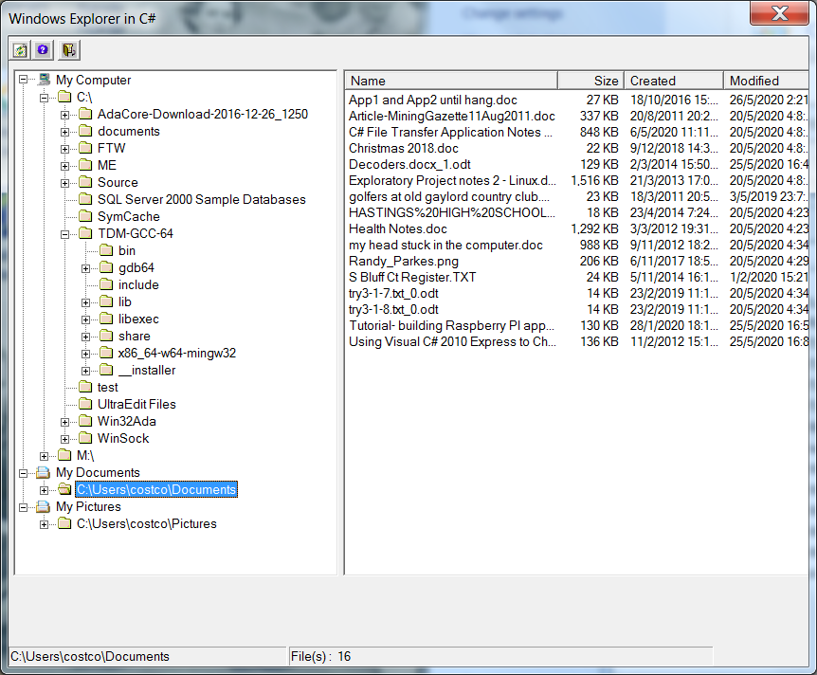

showing My Computer with the C:\ and M:\ drives with M:\ not expanded as well as the new My Documents and My Pictures root notes with the files directly under Documents displayed in the List View (without the two files to be ignored as specified in the unseen portion of IgnoreDirectory.dat).

As can be seen in the above tree view image (the left panel of the split panel) I have added an additional image to precede the My Documents and My Pictures root node names. It took a bit of time to figure out how to do this.
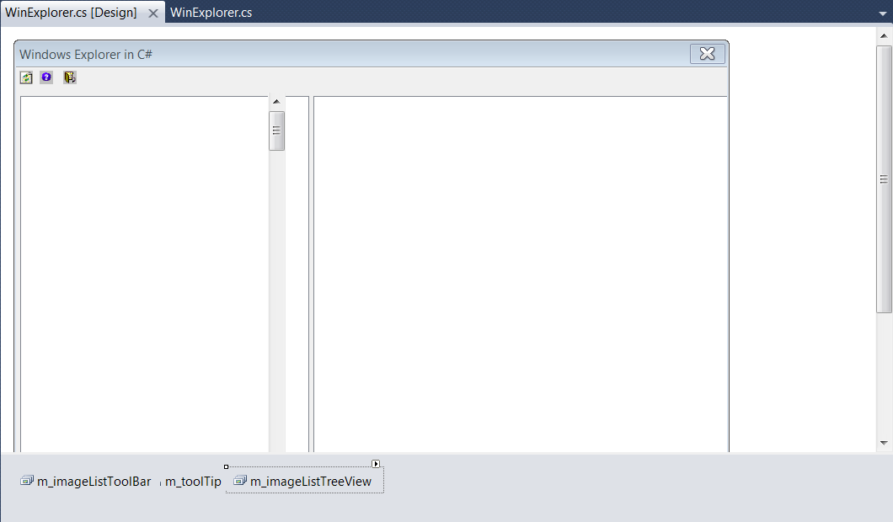

The above is a view of the WinExplorer.cs [Design] of K Niranjan Kumar's application. To add images to be displayed the m_imageListTreeView link at the bottom of the form has to be clicked to bring up its Properties panel. Then, under Images towards the middle of the panel is (Collection) with a … button visible at the right edge when the line is clicked. Clicking on the button brings up an Images Collection Editor where images can be added or removed.

When I first found this I tried a sample edit and, in doing so, I got some of the indexes associated with the images rearranged. Afterwards I started getting the recycle bin image in place of the folder image and the closed folder image when the open image should have been displayed. It was a day or three before I recognized this and a further time before I recognized why it must have happened. Therefore, in comparing my code with that of the original application it can be noticed that different image indexes are used which was done to correct for the new associations.

I present the steps here on how to add images since by the time I wanted to add a new image for the new root nodes I had forgotten how I got to the correct set of properties in order to do so and had to do trial and error again to find the correct Properties panel.

One final display of this post is the form as it appears when the application completes populating the tree view and allows the user to know it is actually doing something.

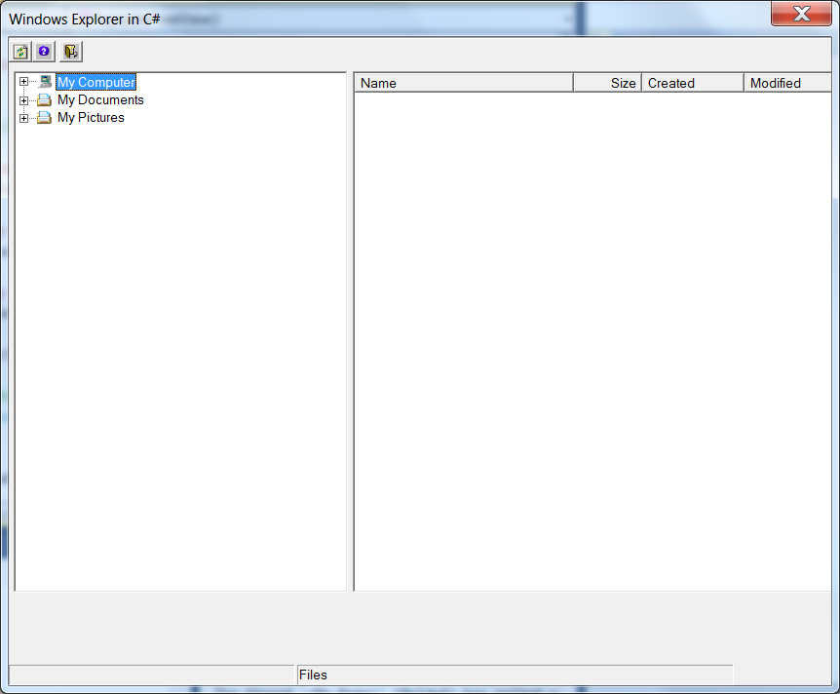

As I wrote the above snide comment "and allows the user to know it is actually doing something" a thought occurred to me that perhaps I could make the user aware that WinExplorer was doing something. That is, although the code output to the lower left control "Refreshing Folders and Files. Please wait...", it was never seen since the form never displayed until the populating of the folders completed and the waiting was over. Thus I set out to see if I could and quickly discovered that it was possible.

Instead of populating the now three root nodes before allowing the form to be displayed, I changed the application to only display the root nodes upon launch. Since there was no real tree as yet the tree view displayed a little different. Then I had to have an asynchronous way of causing the populating to occur while the "Refreshing Folders and Files. Please wait..." message was being displayed. I first tried to use a timer event but decided instead to let the user trigger the root node computer drives or its root folder initial PopulateFolders invocation. This worked like a charm and made me wonder why my former attempts to let the user choose the path to be followed had failed.
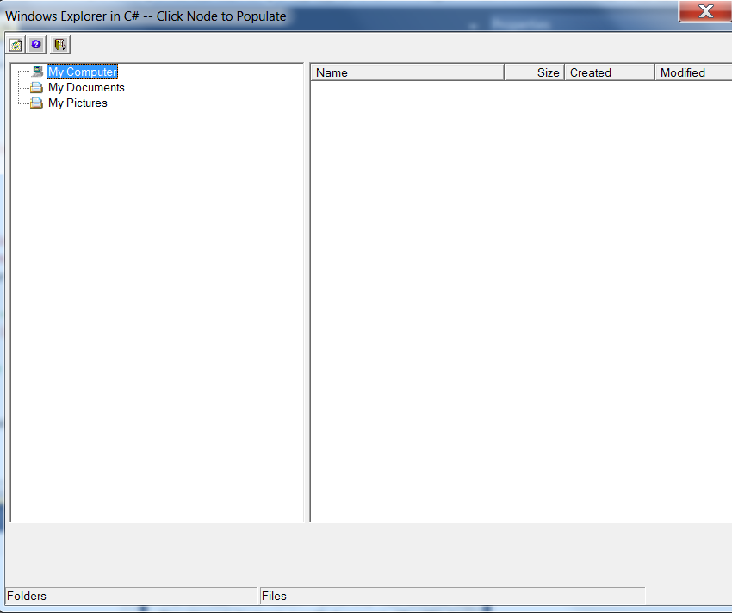

As can be seen, I chose to prompt the user via the form's title to click on the particular node to be populated.

After the user does so, the "Refreshing Folders and Files. Please wait..." message now appears in the right lower control in place of "Files" while the root node that was selected appears in the lower left control.

After the selected node has been populated, in this case My Computer, the tree begins to look more normal. The title reverts to just "Windows Explorer in C#" without the "prompt", My Computer gets the plus box showing that it has child drives and folders, My Computer shows in the lower left as the selected node, and the Please wait… has been removed from the right.

If the other root nodes are clicked, they will get their Please wait… notification until the selected node is populated and the node will then get its plus box. If the third node is selected, the form will display as in the previous sample images.

This allows the user to see the form at the start and to see "Please wait…" to know there is an expected delay. And a shorter wait if only one of the root nodes is of interest.

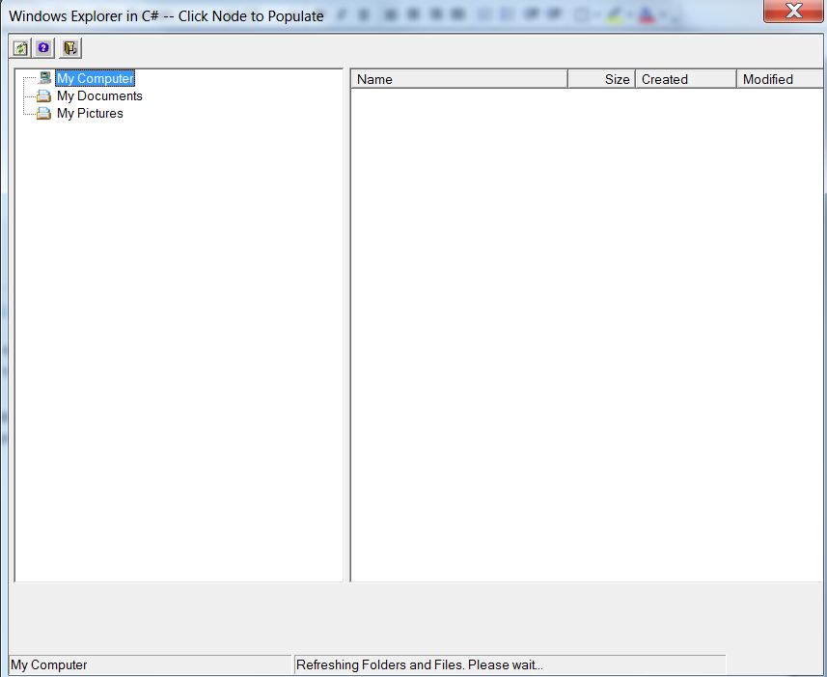

Following the population of the computer drives of the My Computer root node and their folders/directories, the following image was displayed.

Thus the user can specify what they need and shorten the delay. In the case of My Pictures on my PC, this occurred before I could react to the "Please wait".
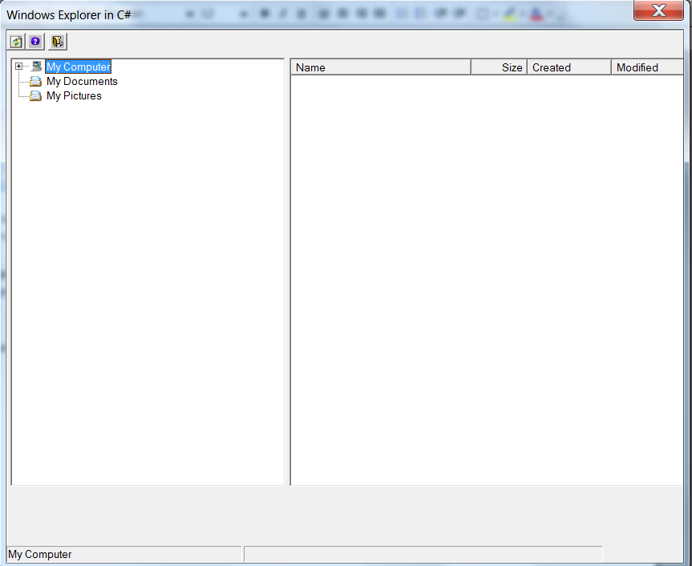

Code available upon request.

